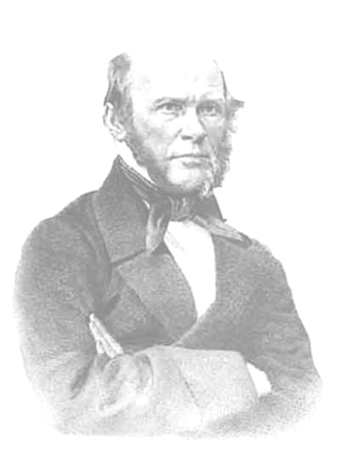
PIROGOV READINGS
Information Letter No. 1

Federal State Budgetary Educational Institution of Higher Education
«Privolzhsky Research Medical University»
of the Ministry of Health of the Russian Federation

Dear colleagues!

We are pleased to inform you of

PIROGOV READINGS

28th Scientific Conference of Students and Young Researchers
with international participation
to be held
in November 2022
The main subjects of the conference are:
- N.I. Pirogov’s traditions in medicine. The history of medicine and healthcare.
- Philosophical and ethical problems of modern times.
- Man in the cultural field.
- Current problems of bioethics.
- The history of Russia: people, events, points of view.
- Global problems of world civilization (in English and German).
- Medicine and science of the 21st century: interdisciplinary discourse (for postgraduate and graduate students).

Working languages: Russian, English.

We would like to invite students, including graduates and postgraduates,
to participate in the conference
(with a maximum of 2 participants from an educational institution)

The collection of materials will be assigned an ISBN identifier.
The collection of materials of the conference will also be included in the database of Russian Science Citation Index (RSCI).

Registration and abstract submission are open until October 6, 2022 via email nipirogov2009@yandex.ru

Please kindly email 2 files:
1. information about the author(s) and scientific advisor;
2. scientific paper (2 authors maximum).
SUBMISSION REQUIREMENTS FOR PARTICIPANTS

The paper should not exceed 4 pages.
The text should be typed with Times New Roman font, font size – 14, line spacing – 1.5, margins – 2 cm each. For references: Times New Roman font, font size 12, line spacing – 1.
The title of the paper should be typed in capital letters, center alignment, without paragraph indention.

Under the heading, the authors’ full names and affiliation should be indicated (Times New Roman, font size 12, center alignment, without paragraph indention).

The paper should also include a brief abstract (2–3 sentences) and key words (3–5 words).

Page numbers and hyphenation are not allowed.

Citations should be put in brackets in the text in correspondence with the source mentioned in references [1, p. 252] at the end of the sentence. Other forms of citation are not allowed. References should be put in alphabetical order at the end of the paper. References should only include the sources cited in the text.

The paper submitted should always be accompanied by the following information about the author(s) and scientific advisor: full name, status (for authors), degree (for scientific advisors), affiliation, contacts (phone numbers and email).
All the submissions are checked for plagiarism. The text should have at least 60 per cent originality rate.
The organizational committee reserves the right to dismiss the papers submitted beyond the deadline (October 6, 2022), as well as those incompliant with the conference subjects, the overall level of the conference, or failing to meet the submission requirements.

PAPER SUBMISSION EXAMPLE
УДК 106.3
FREEDOM OF CREATIVITY AS A PHILOSOPHICAL PROBLEM
[Space]
Ivanov Ivan I.
Student, Privolzhsky Research Medical University (603005, Nizhny Novgorod, Minin Sq., 10/1). Email: ivanovaa@yandex.ru
[Space]
The article is devoted to consideration of one of the most relevant philosophical problems today – human freedom in its relation to creative activity. The author traces the evolution of views on the essence of creativity in the Western and Russian philosophical tradition. It is concluded that a divide between creativity and realization of one’s freedom is impossible.
Key words: freedom, creativity, philosophy, man.
[Space]
Text [1, p. 465]. Text. Text. Text [2]. Text. Text. Text [3, p. 55].
Text. Text. Text [1]. Text. Text. Text [2]. Text. Text. Text. Text. Text. Text. Text. Text. Text. Text. Text [3, p. 120].
[Space]
References
1. Ahagari, N. Personalized medicine in hypercholesterolaemia: the role of pharmacogenetics in statin therapy / N. Ahagari, M. Doosty // Annals of medicine. – December 2020. – V. 52(8). – P. 462–470.
2. Ibrahim, M.A. Hypercholesterolemia / Michael A. Ibrahim, Edinen Asuka, Ishwarlal Jialal // URL: https://www.ncbi.nlm.nih.gov/books/NBK459188/ (referral date: 01.10.2021).
3. Weber, M. Basic sociological concepts. Selected works / M. Weber. – Moscow: Progress, 1990. – 624 p.

